A Mini Project Report on
Secure deduplication with efficient user revocation in cloud storage
Submitted to
Jawaharlal Nehru Technological University, Hyderabad in partial fulfilment of the requirements for the award of the degree

BACHELOR OF TECHNOLOGY
in
COMPUTER SCIENCE & ENGINEERING
by
Parimi Venakta Koushik Roll No.: 22831A05E6
Pragnapuram Varun Sai Roll No.: 22831A05F3
Roll No.:22831A05G0
Mangipudi Ram Pranith
Under the Esteemed Guidance of

Mr.E.Raju
Associate Professor – Department of Computer Science and Engineering



DEPARTMENT OF COMPUTER SCIENCE & ENGINEERING

GURU NANAK INSTITUTE OF TECHNOLOGY
(Affiliated to JNTUH-Hyderabad)
Ranga Reddy District-501506

May 2025


GURU NANAK INSTITUTE OF TECHNOLOGY
(Affiliated to JNTUH-Hyderabad)
Ranga Reddy District-501506

DEPARTMENT OF COMPUTER SCIENCE & ENGINEERING

CERTIFICATE
This is to certify that the project entitled " Secure deduplication with efficient user revocation in cloud storage" is being presented with a report by Parimi Venkata Koushik (22831A05E6), Pragnapuram Varun Sai (22831A05F3), M Ram Praneeth (22831A05G0), in partial fulfillment for the award of Degree of Bachelor of Technology in Computer Science and Engineering, to Jawaharlal Nehru Technological University, Hyderabad.

Mr. E. RAJU Dr. B. SANTHOSH KUAMR
INTERNAL GUIDE EXTERNAL GUIDE

EXTERNAL EXAMINER


PROJECT COMPLETION CERTIFICATE

This is to certify that the following students of 3rd year B.Tech, Department of Computer Science and Engineering. Guru Nanak Institute of Technology (GNIT) have completed their training and project at GNIT successfully.
STUDENT NAME: ROLL NO:
22831A05E6
Parimi Venkata Koushik

- ___________________ ____________
22831A05F3

Pragnapuram Varun Sai
2. ___________________ ____________
22831A05G0

Mangipudi Ram Pranith
3. ___________________ ____________
JAVA
The training was conducted on _________ Technology for the completion of the project titled on Secure deduplication with efficient user revocation in cloud storage in 2025-2026. The project has been completed in aspects.

Declaration of Student

We hereby declare that the minor project report entitled " Secure deduplication with efficient user revocation in cloud storage" is the work done by Parimi Venkata Koushik, Pragnapuram Varun Sai , Mangipudi Ram Praneeth bearing the roll no's 22831A05E6, 22831A05F3, 22831A05G0 towards the fulfilment of the requirement for the award of the Degree of Bachelor of Technology in Computer Science and Engineering, to Jawaharlal Nehru Technological University, Hyderabad, is the result of the work carried out under the guidance Mr. E. Raju, Associate Professor – Department of Computer Science and Engineering Guru Nanak Institute of Technology, Hyderabad.
I/We confirm the following:
- I have contributed the entire project process, from the selection of the project title to the submission of the final report.
- The project report has been prepared as per guidelines, ensuring adherence to high standards of quality, clarity, and structure.
- All information provided and work done is completely genuine and is not copied from any online or offline platform.
- That I or any of my known have not submitted this project to any other University or College.
I further certify that this project report has not been previously submitted in part or full for the award of any degree or diploma by any institution or university.

22831A05E6 22831A05F3 22831A05G0
Parimi Venkata Koushik Pragnapuram Varun Sai Mangipudi Ram Praneeth

DECLARATION BY GUIDE
I, Mr E. Raju, hereby declare that I have guided the minor project titled " Secure deduplication with efficient user revocation in cloud storage " Undertaken By Parimi Venkata Koushik (22831A05E6), Pragnapuram Varun Sai (22831A05F3), M Ram Praneeth (22831A05G0). This project was carried out towards the fulfillment of the requirements for the award of the Degree of Bachelor of Technology in Computer Science and Engineering, to Jawaharlal Nehru Technological University, Hyderabad.
As the guide, I confirm the following:
- I have overseen the entire project process, from the selection of the project title to the submission of the final report.
- I have reviewed and certified the accuracy and relevance of the results presented in the report.
- The work carried out is original, free from plagiarism, and adheres to ethical guidelines.
- The contributions of each student have been appropriately recognized and assessed.
- The project report has been prepared under my supervision, ensuring adherence to high standards of quality, clarity, and structure.
I further certify that this project report has not been previously submitted in part or full for the award of any degree or diploma by any institution or university.

Name of Guide: Mr. E. Raju
Date:
Place: Signature of the Guide

Name of HOD: Dr. B. Santhosh Kumar
Department: Computer Science & Engineering
Date:
Place: Signature of the HOD.

ACKNOWLEDGEMENT
"Task successful" makes everyone happy. But the happiness will be gold without glitter if we didn't state the persons who have supported us to make it a success.
We would like to express our sincere thanks to Dr. B. SANTHOSH KUMAR, Professor & Head - Department of Computer Science and Engineering, Guru Nanak Institute of Technology for having guided me in developing the requisite capabilities for taking up this project.
We thank Project Coordinator Mr. G. Lakpathi, Assistant Professor CSE, GNIT for providing seamless support and right suggestions that are given in the development of the project.
We specially thank our internal guide Mr. E. Raju, Associate Professor – Department of Computer Science and Engineering for his constant guidance in every stage of the project. We would also like to thank all our lecturers for helping me in every possible way whenever the need arose.
On a more personal note, we thank our beloved parents and friends for their moral support during the course of our project.

GURU NANAK INSTITUTE OF TECHNOLOGY
(Affiliated to JNTUH-Hyderabad)
Ranga Reddy District-501506

CO-PO MAPPING
COs | Course Outcome | BL
CO1 | Independently carry out literature survey in identified domain, and consolidate it to formulate a problem statement | 4
CO2 | Apply identified knowledge to solve a complex engineering problem and design a solution, implement and test the proposed solution | 3
CO3 | Use synthesis/Modeling to simulate and solve a problem or apply appropriate method of analysis to draw valid conclusions and present, demonstrate, execute final version of project | 3
CO4 | Contribute effectively as a team member or leader to manage the project timeline and Incorporate the social, environmental and ethical issues effectively into solution of an engineering problem | 6
CO5 | Write pertinent project reports and make effective Project Presentations | 3

COs | PO1 | PO2 | PO3 | PO4 | PO5 | PO6 | PO7 | PO8 | PO9 | PO10 | PO11 | PO12 | PSO1 | PSO2 | PSO3
CO1 | – | 3 | – | – | – | – | – | – | – | – | – | 3 | 3 | 3 | 3
CO2 | 3 | – | 3 | – | – | – | – | – | – | – | – | – | 3 | 3 | 3
CO3 | – | – | – | 3 | 3 | - | - | - | – | – | – | – | 3 | 3 | 3
CO4 | – | – | – | – | – | 3 | 3 | 3 | 3 | – | 3 | – | – | 3 | –
CO5 | – | – | – | – | – | – | – | – | – | 3 | – | – | – | 3 | –

GURU NANAK INSTITUTE OF TECHNOLOGY
(Affiliated to JNTUH-Hyderabad)
Ranga Reddy District-501506

DEPARTMENT OF COMPUTER SCIENCE & ENGINEERING

VISION
To be recognized as a leading department of Computer Science and Engineering in the region by students, employers and be known for leadership, Ethics, and commitment to fostering quality teaching-learning, research, and innovation.

MISSION

- Nurture young individuals into knowledgeable, skill-full and ethical professionals in their pursuit of Computer Science and Engineering.
- Nurture the faculty to expose them to world-class infrastructure.
- Sustain high performance by excellence in teaching, research and innovations.
- Extensive partnerships and collaborations with foreign universities for technology upgradation.
- Develop Industry-Interaction for innovation and product development.

ABSTRACT
Users want to keep encrypted data on cloud servers to preserve data privacy. By removing duplicate copies, cloud servers lower the cost of storage and network traffic. This paper introduces the notion of clustering deviation as a potential solution to the internal data leaking issue. We enhance the dbscan technique to accommodate variations in clustering. Using people as clustering samples, the new technique forms the basis of a data deduplication scheme. To assign new users to the existing classes, a certain variation is allowed rather than simply re-clubbing them. We use user-clustering results to evaluate the popularity of the data and implement various encryption algorithms to better secure the security of unpopular material. Through trials, the algorithm's performance is examined and contrasted with alternative approaches; the findings confirm the viability and effectiveness of the suggested deduplication scheme.

TABLE OF CONTENT

S.NO | CONTENT |  |  |  | PG.NO
 | Certificate |  |  |  | i
 | Declaration by the Students |  |  |  | ii
 | Declaration by the Guide |  |  |  | iii
 | Acknowledgement |  |  |  | iv
 | CO-PO Mapping |  |  |  | v
 | Department Vision & Mission |  |  |  | vi
 | Abstract |  |  |  | vii
 | Table of Content |  |  |  | viii
 | List of Figures |  |  |  | x
 | List of Tables |  |  |  | xi
 | Abbreviations/ Notation |  |  |  | xii
1 | CHAPTER 1: INTRODUCTION |  |  |  | 1
 | 1.1 | OBJECTIVE |  |  | 2
 | 1.2 | FEASIBILITY STUDY |  |  | 3
 |  | 1.2.1 |  | Types of Feasibility Study | 4
 |  | 1.2.2 |  | Blockchain Technology | 7
 |  | 1.2.3 |  | DBSCAN | 9
2 | CHAPTER 2: LITERATURE SURVEY |  |  |  | 11
 | 2.1 | LITERATURE SURVEY |  |  | 11
 | 2.2 | SCOPE OF PROJECT |  |  | 14
 |  | 2.2.1 |  | Problem Statement | 14
 |  | 2.2.2 |  | Existing System | 15
 |  | 2.2.3 |  | Disadvantages of Existing System | 15
 | 2.3 | PROPOSED SYSTEM |  |  | 15
 |  | 2.3.1 | Advantages of Proposed System |  | 16
 | 2.4 | REQUIREMENTS |  |  | 16
 |  | 2.4.1 |  | Software requirements | 16
 |  | 2.4.2 |  | Hardware requirements | 16
 |  | 2.4.3 |  | Functional requirements | 17
 |  | 2.4.4 |  | Non-Functional requirements | 17
 | 2.5 | METHODOLOGY |  |  | 18
 |  | 2.5.1 |  | Modules name | 18
 |  | 2.5.2 |  | Modules explanation | 18
 | 2.6 | TECHNIQUES OR ALGORITHMS |  |  | 19
3 | CHAPTER 3: DESIGN AND DEVELOPMENT |  |  |  | 20
 | 3.1 | SYSTEM ARCHITECTURE |  |  | 20
 | 3.2 | GENERAL - UML DIAGRAMS |  |  | 21
 |  | 3.2.1 |  | Use case Diagram | 21
 |  | 3.2.2 |  | Class Diagram | 22
 |  | 3.2.3 |  | Object Diagram | 23
 |  | 3.2.4 |  | Component Diagram | 23
 |  | 3.2.5 |  | Deployment Diagram | 24
 |  | 3.2.6 |  | Sequence Diagram | 25
 |  | 3.2.7 |  | Collaboration diagram | 26
 |  | 3.2.8 |  | State Diagram | 27
 |  | 3.2.9 |  | Activity Diagram | 28
 | 3.3 | Data Flow Diagram |  |  | 29
 | 3.4 | E-R Diagram |  |  | 31
4 | CHAPTER 4: RESULTS & DISCUSSION |  |  |  | 33
5 | CHAPTER 5: CONCLUSION |  |  |  | 41
 | 5.1 | CONCLUSION |  |  | 41
 | 5.2 | FUTURE ENHANCEMENTS |  |  | 41
 | References |  |  |  | 42

LIST OF FIGURES

FIGURE NO | NAME OF THE FIGURE | PAGE NO.
3.1 | System Architecture | 17
3.2.1 | Use case Diagram | 18
3.2.2 | Class Diagram | 19
3.2.3 | Object Diagram | 20
3.2.4 | Component Diagram | 20
3.2.5 | Deployment Diagram | 21
3.2.6 | Sequence Diagram | 22
3.2.7 | Collaboration Diagram | 23
3.2.8 | State Diagram | 24
3.2.9 | Activity Diagram | 25
3.3 | Data Flow Diagram | 26
3.4 | E-R Diagram | 38

LIST OF TABLES

TABLE NO | NAME OF THE TABLE | PAGE NO.
2.4.1 | Software Requirements | 13
2.4.2 | Hardware Requirements | 13
2.4.3 | Functional Requirements | 14
2.4.4 | Non-Functional Requirements | 14

LIST OF ABBREVATION
S.NO | ABBREVATION | EXPANSION
1. | DB | Database
2. | JVM | Java Virtual Machine
3. | JSP | Java Server Page
4. | PWS | Personalized Web Search
5. | UPS | User Personalized Search
6. | JRE | Java Runtime Environment

CHAPTER 1
INTRODUCTION

The development and application of cloud computing have led more and more users to store their data on the cloud server (CS). To save bandwidth and storage space, servers usually use data deduplication techniques, i.e., they maintain only a single copy of data and remove redundancy. However, when uploading data to the CS, users want to encrypt the data to protect their privacy and prevent the data content from being obtained by CS or other attackers. However, with traditional encryption schemes, users randomly select keys and encrypt the plaintext. This makes the cipher text stored on the CS different even for the same plaintext, which makes the deduplication operation very difficult. Conversely, when users encrypt the data with the same key, this can significantly reduce the security of the system. Convergent encryption (CE) was proposed to solve this problem effectively. In CE, the key is derived from the plaintext, so that the same plaintext produces the same key, which in turn produces the same cipher text. This allows data deduplication of encrypted data. However, CE has security flaws and is vulnerable to offline brute-force attacks, because the key derivation process is deterministic. In recent years, many researchers have worked on designing various Message-Locked Encryption (MLE)-based deduplication schemes. In response to the above attacks, Stanek et al. proposed a deduplication scheme based on popularity division. Data with different popularity are encrypted using different encryption methods to further save cloud storage space and network bandwidth. Puzio et al. proposed a ClouDedup scheme with a metadata manager and an additional server defined in the CS: the server adds an encryption layer to prevent attacks against CE and thus protects the confidentiality of data. DupLESS used a key manager to generate the key and applies the oblivious pseudorandom function (OPRF), which is a high-security algorithm. The scheme of Zhang et al. used elliptic curve encryption algorithm to achieve data confidentiality, and different encryption methods were used for popular and unpopular data to reduce the computational overhead. Liu et al. proposed a secure data deduplication scheme that does not require a third-party server. This scheme adopts password-authenticated key exchange (PAKE) to implement cross-user key passing, thus achieving cross-user data deduplication. And it also eliminates the dependence on third-party servers and improves security. However, it requires all users involved in the protocol to be online when exchanging keys, which significantly increases the communication overhead and reduces the practicality. Various existing data deduplication schemes focus on the protection and delivery of encryption keys and the identification of duplicate data while ignoring the impact of users on deduplication. Among the many schemes that differentiate data according to their popularity, for the data with fewer holders, a semantic security-compliant encryption scheme with higher security is used. When the number of data holders increases, the system considers that the data is less sensitive and uses a less secure encryption protection scheme such as CE. However, if the data belong to users from the same organization, such as a company’s internal address book, the case will be different. That is, the increase in the number of data holders does not mean that its sensitivity decreases. If the system uses a less secure encryption protection scheme, it will cause the potential internal data leakage.

1.1 OBJECTIVE
In the information age, determining the validity of data information and the efficacy of data transmission interoperability, as well as confirming the credibility of information sharing, is critical to the survival and development of businesses. In this setting, block chain technology is implemented, and its benefit is that it implies genuine data information sharing is done in an undesirable atmosphere. To better comprehend the quality and data management mechanisms of manufacturing suppliers under the block chain, this chapter first covers supply chain quality management. The block chain infrastructure and core technologies are then dug into. Finally, the block chain is evolving in the industrial supply chain.
1.2 FEASIBILITY STUDY
Conventional DBSCAN algorithm require re-clustering when the data set is changed, which will greatly increase the computational overhead of the system. We first propose the concept of clustering deviation, i.e., ignoring certain errors and preferentially classifying newly added points into their nearby classes or treating them as noise points. Based on this, we designed a DBSCAN algorithm with tolerable clustering deviation algorithm.
1.2.1 Types of feasibility studies and their application
1. Technical Feasibility
Purpose: To assess whether the technological resources and expertise are available to implement the system.
Application:
- Availability of cryptographic libraries (e.g., OpenSSL, Bouncy Castle) to implement secure deduplication and encryption mechanisms.
- Proficiency in implementing deduplication techniques such as convergent encryption and server-side indexing.
- Availability of cloud infrastructure platforms (e.g., AWS S3, Azure Blob Storage, Google Cloud Storage) to deploy and test the system.
- Capability to enforce secure and scalable user revocation protocols, including key management and revocation list updates.
- Integration potential with identity-based encryption or CP-ABE (Ciphertext-Policy Attribute-Based Encryption) for fine-grained access control.
2. Economic Feasibility
Purpose: To determine whether the project is economically viable and cost-effective.
Application:
- Cost analysis of cloud storage services, compute instances, and data transfer bandwidth.
- Expenses related to implementing and maintaining encryption and deduplication modules.
- Reduced storage costs through effective deduplication, leading to long-term savings.
- Minimized data breach risks and associated financial losses due to enhanced data security.
- Economic benefits from improved trust and regulatory compliance, particularly for enterprise use cases.
3. Operational Feasibility
Purpose: To assess whether the project will operate effectively once implemented.
Application:
- Simple and secure interfaces for data owners to upload and deduplicate encrypted files.
- Efficient revocation mechanisms to ensure former users cannot access deduplicated content post-revocation.
- Reliable index management and integrity checks to support deduplication without compromising security.
- Seamless experience for authorized users to retrieve and decrypt content without performance bottlenecks.
- Automation of key updates and revocation workflows to minimize administrative burden.
4. Legal Feasibility
Purpose: To check for any legal or regulatory constraints that could impact the project.
Application:
- Ensuring compliance with international and regional data protection laws such as GDPR, HIPAA, or India's Data Protection Act.
- Adherence to licensing requirements of third-party encryption and deduplication libraries.
- Secure handling of metadata and key materials to protect user privacy in shared storage environments.
- Transparency in access and revocation logs to aid in regulatory audits and user accountability.
- Schedule Feasibility
Purpose: To estimate whether the project can be completed within a reasonable timeframe.
Application:
- Timeline for implementing deduplication algorithms, encryption modules, and key revocation logic.
- Development and integration of secure indexing and access verification features.
- Adequate buffer for UI/UX design, usability testing, and performance optimizations.
- Time allocation for testing across various scenarios (e.g., revocation mid-session, concurrent uploads).
- Documentation, user training, and feedback incorporation phases to ensure operational readiness.
Overall Feasibility Conclusion:
The project “Secure Deduplication with Efficient User Revocation in Cloud Storage” is highly feasible across technical, economic, operational, legal, and scheduling dimensions. It leverages mature cryptographic techniques and cloud infrastructure to achieve secure storage optimization while ensuring granular access control and timely revocation. By addressing the challenges of data redundancy, unauthorized access, and compliance, the project offers a modern, cost-effective, and scalable solution for secure cloud data management.
1.2.2 BLOCKCHAIN TECHNOLOGY
A Blockchain is a decentralized ledger technology designed to provide tamper-proof, transparent, and verifiable record-keeping. In this project, blockchain serves as the foundation for enforcing and auditing access control policies over encrypted data in the cloud.
Role in the Project:
- Decentralized Access Control: Access policies are stored on a public or consortium blockchain to eliminate central authority dependency.
- Immutable Logging: Every data access or modification attempt is recorded immutably for future audits.
- Smart Contracts: Automated scripts enforce attribute-based access permissions and handle secure data retrieval triggers.
- Verification Mechanism: Data owners can verify that access policies were enforced without trusting the cloud provider.
Benefits:
- Trust less Security: No need to trust a third party; users rely on cryptographic proofs and blockchain consensus.
- Tamper-Resistance: Data policies and access logs are resistant to manipulation or deletion.
- Transparency and Auditability: Provides users with full traceability of who accessed what data and when.
- Enhanced Collaboration: Enables secure sharing across multiple users or organizations without centralized control.
Challenges:
- Latency and Throughput: Public blockchains can have high confirmation times and low transaction throughput.
- Cost Management: Blockchain operations (e.g., smart contract execution) can incur costs (e.g., gas fees in Ethereum).
- Scalability: Managing large access policies and frequent updates may require off-chain enhancements.
1.2.4 DBSCAN (Density-Based Spatial Clustering of Applications with Noise)
DBSCAN is a popular unsupervised machine learning algorithm used for clustering data points based on their density. It is highly effective for discovering clusters of arbitrary shapes and identifying noise or outliers in datasets.

Role in the Project:
- Anomaly Detection in Storage Access: DBSCAN can be used to detect unusual patterns in cloud storage access logs, helping to flag potential data breaches or unauthorized access attempts.
- Deduplication Optimization: It can identify clusters of similar files or access patterns, optimizing the deduplication process by grouping redundant or related data.
- User Behaviour Clustering: Group users based on access behavior or usage attributes to customize revocation or access control policies more intelligently.
Architecture:
- Input Dataset: Consists of data points such as file access times, file sizes, hash similarities, or user activity logs.
- Epsilon (ε): Defines the maximum distance between two points to be considered part of the same neighbourhood.
- MinPts: Minimum number of points required to form a dense region (cluster).
- Core Points: Data points with at least MinPts neighbours within ε distance.
- Border Points: Points that are within ε of a core point but have fewer than MinPts neighbours themselves.
- Noise Points: Points that do not belong to any cluster.
Benefits:
- Noise Identification: Unlike k-means, DBSCAN can detect and label outliers as noise, which is useful in security applications.
- No Need for Predefined Clusters: DBSCAN does not require specifying the number of clusters beforehand, making it ideal for exploratory data analysis.
- Non-Linear Cluster Shapes: Effectively identifies clusters of arbitrary shapes, unlike algorithms that assume spherical clusters.
- Versatility: Can be applied to multi-dimensional datasets in cloud access monitoring, file similarity detection, etc.
Challenges:
- Parameter Sensitivity: Choosing appropriate values for ε and MinPts is critical and often requires domain-specific tuning.
- High-Dimensional Data: DBSCAN’s effectiveness can diminish in high-dimensional spaces due to the curse of dimensionality.
- Varying Density Clusters: May struggle to separate clusters with significantly different densities.

CHAPTER 2
2.1 LITERATURE SURVEY
[1] Y. Fan, X. Lin, W. Liang, G. Tan, and P. Nanda, “Deduplication on encrypted big data in cloud,” 2020.
Title: Deduplication on encrypted big data in cloud
This paper proposes a secure deduplication scheme based on a Trusted Execution Environment (TEE) to address data confidentiality concerns in cloud storage. The scheme assigns privilege sets to cloud users, allowing deduplication only if users possess the correct privileges. It enhances convergent encryption with user privileges and leverages TEE for secure key management, improving resistance against chosen plaintext and chosen ciphertext attacks. Security analysis and prototype implementation confirm its security and practical overhead for big data deduplication.
[2] Z. Yan, W. Ding, X. Yu, H. Zhu, and R. H. Deng, “R-dedup: Secure client-side deduplication for encrypted data without involving a third-party entity,” 2016.
Title: R-dedup: Secure client-side deduplication for encrypted data without involving a third-party entity
This work introduces a scheme for duplicating encrypted data in the cloud, integrating data deduplication with access control. It addresses the limitations of existing solutions that struggle with flexible data access control and revocation. The proposed scheme is based on ownership challenge and proxy re-encryption, demonstrating superior efficiency and effectiveness for big data deduplication in cloud storage through extensive analysis and simulations.
[3] C. Guo, X. Jiang, K.-K.-R. Choo, and Y. Jie, “R-dedup: Secure client-side deduplication for encrypted data without involving a third-party entity,” 2020.
Title: R-dedup: Secure client-side deduplication for encrypted data without involving a third-party entity
This paper proposes R-Dedup, a randomized, secure, cross-user deduplication scheme that operates without involving any third-party entity or requiring assistance from other users. It tackles the challenge of deduplicating encrypted data where different keys might be used for the same content. The scheme leverages ElGamal encryption to enable users with identical file copies to share the same random value, ensuring data privacy and integrity while being lightweight.
[4] X. Tang, L. Zhou, B. Hu, and H. Wu, “Aggregation-based tag deduplication for cloud storage with resistance against side channel attack,” 2021.
Title: Aggregation-based tag deduplication for cloud storage with resistance against side channel attack
This study presents a secure aggregation-based tag deduplication scheme (ATDS) that specifically addresses resistance against side-channel attacks during public verification. It defines a user-associated integrity tag based on a content-associated polynomial and employs a Lagrangian interpolation-based aggregation strategy for tag deduplication. This allows for the use of a content-associated public key for auditing, ensuring that a malicious third-party auditor can only confirm data correspondence to a group of users, not specific owners, thus protecting existence privacy. The scheme is shown to be more efficient and secure against side-channel attacks.
[5] J. R. Douceur, A. Adya, W. J. Bolosky, P. Simon, and M. Theimer, “Reclaiming space from duplicate files in a serverless distributed file system,” 2002.
Title: Reclaiming space from duplicate files in a serverless distributed file system
This foundational paper introduces a mechanism to reclaim space from incidental duplication in the Farsite distributed file system, which uses replication for availability. The mechanism includes convergent encryption, enabling the coalescing of duplicate files even if encrypted with different user keys, and SALAD (Self-Arranging Lossy Associative Database) for decentralized, scalable, and fault-tolerant aggregation of file content and location information. Large-scale simulations confirm its scalability, effectiveness, and fault tolerance.
[6] D. Ivanov, A. Dolgui, and B. Sokolov, “Secure cloud data deduplication with efficient re-encryption,” 2019.
Title: Secure cloud data deduplication with efficient re-encryption
This paper focuses on secure and efficient re-encryption in encrypted data deduplication systems. It identifies a vulnerability (stub-reserved attack) in a recently designed scheme (REED) and proposes a new secure data deduplication scheme based on the convergent all-or-nothing transform (CAONT) and randomly sampled bits from the Bloom filter. The proposed scheme resists the stub-reserved attack and guarantees data privacy. By requiring data owners to re-encrypt only a small part of the package through CAONT, it significantly reduces computation overhead, making it both secure and efficient in re-encryption.
2.2 SCOPE OF THE PROJECT
Conventional DBSCAN algorithm require re-clustering when the data set is changed, which will greatly increase the computational overhead of the system. We first propose the concept of clustering deviation, i.e., ignoring certain errors and preferentially classifying newly added points into their nearby classes or treating them as noise points. Based on this, we designed a DBSCAN algorithm with tolerable clustering deviation algorithm. First, a conventional DBSCAN clustering is performed on the currently existing data set; thereafter, whenever a new point q appears, instead of re-clustering, the operation.
2.2.1 PROBLEM STATEMENT
With the increasing reliance on cloud storage services, ensuring the confidentiality, integrity, and accessibility of sensitive data has become a critical challenge. Traditional cloud security models often depend on centralized authorities, which are vulnerable to data breaches, unauthorized access, and single points of failure. Furthermore, these systems may lack transparency and traceability in data access and modification. Therefore, there is a need for a decentralized, secure, and auditable system that can enhance trust and data protection in cloud environments. This project aims to develop a blockchain-based approach to secure cloud data by leveraging its distributed ledger, cryptographic integrity, and smart contracts to ensure secure data sharing, authentication, and access control without relying on centralized entities.

2.1.2 EXISTING SYSTEM:
However, with traditional encryption schemes, users randomly select keys and encrypt the plaintext. This makes the ciphertext stored on the CS different even for the same plaintext, which makes the deduplication operation very difficult. Conversely, when users encrypt the data with the same key, this can significantly reduce the security of the system. Convergent encryption (CE) was proposed to solve this problem effectively. In CE, the key is derived from the plaintext, so that the same plaintext produces the same key, which in turn produces the same ciphertext. This allows data deduplication of encrypted data. However, CE has security flaws and is vulnerable to offline brute-force attacks, because the key derivation process is deterministic. In recent years, many researchers have worked on designing various Message-Locked Encryption (MLE)-based deduplication schemes. In response to the above attacks, Stanek et al. proposed a deduplication scheme based on popularity division.
2.2.3 DISADVANTAGES OF EXISTING SYSTEM
- Collection of quality characteristic data, high-speed safe transmission.
- Next-generation information technology.
2.3 PROPOSED SYSTEM
This paper proposes a block chain-based aviation supplier manufacturing process quality data-sharing platform. Firstly, the paper introduces the possibility of integrating manufacturing supply chain quality management with block chain technology. Secondly, the quality and data sharing platform architecture of the production process of new aviation suppliers is presented based on quality state and island kinds of aviation suppliers. Then, a detailed method for the implementation of quality and data security sharing is proposed to support the sharing platform’s real-time and orderly operation. Build critical technologies such as manufacturing quality data block packaging models, data storage security sharing, and supplier assessment models on this foundation. Finally, depending on data collection of supplier product production processes to shared application practices based on a specific aircraft industrial park under the supervision of the platform architecture and technology. The application platform integrates the data supply and request components, providing practical and intelligent sharing solutions for airlines’ product quality data.

2.3.1 ADVANTAGES OF THE PROPOSED SYSTEM
- Sharing platform’s real-time and orderly operation.
- data storage security sharing, and supplier assessment models on this foundation
- providing practical and intelligent sharing solutions for airlines
2.4 REQUIREMENTS
Here's a detailed breakdown of the Requirements:
2.4.1 SOFTWARE REQUIREMENTS
Component | Description
Programming Language | Java
Front End | J2EE (JSP, SERVLET)
IDE/Editor | Eclipse
Database | MY SQL 5.5
Operating System | Windows 10/11, Ubuntu, or macOS

2.4.2 HARDWARE REQUIREMENTS
Component | Specification
Processor | Minimum: Intel i5 or equivalent, Recommended: i7 or better
RAM | Minimum: 8 GB, Recommended: 16 GB or more
Storage | Minimum: 100 GB of free space
Peripherals | Standard keyboard, mouse, display, internet connectivity

2.4.3 FUNCTIONAL REQUIREMENTS
Functionality | Description
Outsourced Computation Security | Ensures that outsourced computation data is securely handled using blockchain technology to prevent unauthorized modifications.
Data Integrity | Blockchain ensures immutability and irreversibility of data, protecting it from tampering and enhancing trust in stored records.
Data Privacy | Since blockchain data is open and transparent, encryption of data and indexes is implemented. Smart contracts enforce access control to protect against unauthorized access.

2.4.4 NON-FUNCTIONAL REQUIREMENTS
Category | Description
Usability | Designed as a fully automated system requiring minimal user interaction, enhancing ease of use and efficiency.
Reliability | Built using Java, which provides platform-independent robustness and enhances the overall reliability of the system.
Performance | Utilizes high-level programming languages and modern front-end/back-end technologies to ensure fast response times for users.
Supportability | Cross-platform compatibility enabled through Java Virtual Machine (JVM) support, allowing the system to run on diverse hardware and operating systems.
Implementation | Developed as a web application using the Struts framework, deployed on Apache Tomcat server, and designed for Windows XP Professional environment.
Interface | User interface is developed using Struts’ HTML Tag libraries to ensure structured and maintainable front-end presentation.

2.5 METHODOLOGY
2.5.1 MODULES NAME:

This project having the following 5 modules:
1. User Interface Design
2. User
3. K-Manager
4. Cloud Server
2.5.2 Modules Explanation
1. User Interface Design: In this module we design the windows for the project. These windows are used for secure login for all users. To connect with server user must give their username and password then only they can able to connect the server. If the user already exits directly can login into the server else user must register their details such as username, password and Email id, into the server. Server will create the account for the entire user to maintain upload and download rate. Name will be set as user id. Logging in is usually used to enter a specific page.
2. User
This is the first module Data User can register and Login. After login Data User have an option of searching the files as a file name. Data user can also have a download file it will show an encrypted data. Data user can also send a trapdoor request to the server. Server can accept the request and then data user can take permissions from the owner then the file it will download in plain text.
3. K-Manager
This is the Second module of this project. In this module Data Owner should register and Login. Data Owner will Uploads the files into the database. Data owner can also send request to the data user.
4. Cloud Server
This is the third module of this project. In this module Cloud Server can login. After login it will see all data owners’ information. Cloud server can see all users’ information. Cloud server can see an all stored data files. Cloud server can give keys request to the user. Cloud server can also see an attacker information of file.

2.6 TECHNIQUE USED OR ALGORITHM USED
- DBSCAN ALGORITHM
DBSCAN (Density-Based Spatial Clustering of Applications with Noise) is a density-based unsupervised clustering algorithm that is useful for clustering non-linear datasets. Unlike k-means clustering, DBSCAN does not require specifying the number of clusters initially. It works by computing nearest neighbor graphs and creating arbitrary-shaped clusters in datasets (which may contain noise or outliers) as opposed to k-means clustering, which typically generates spherical-shaped clusters. DBSCAN clusters are formed from dense regions and separated by regions of no or low densities. The algorithm has two parameters viz. the radius of neighborhoods for a given data point p (eps or ε) and the minimum number of data points in a given ε-neighborhood to form clusters (minPts). DBSCAN is a density-based clustering algorithm that groups together points that are close to each other based on a distance measurement and a minimum number of points. It is an unsupervised machine learning algorithm that can identify clusters of any shape in a dataset containing noise and outliers. Epsilon defines the radius of the neighborhood around each point, while minPts defines the minimum number of points required to form a cluster.

CHAPTER 3
DESIGN AND DEVELOPMENT
GENERAL
Design Engineering deals with the various UML [Unified Modelling language] diagrams for the implementation of project. Design is a meaningful engineering representation of a thing that is to be built. Software design is a process through which the requirements are translated into representation of the software. Design is the place where quality is rendered in software engineering. Design is the means to accurately translate customer requirements into finished product.
3.1 SYSTEM ARCHITECTURE
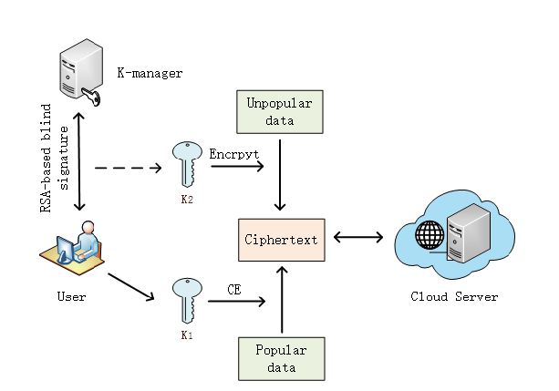
In this project user has a register all details and then login. K-Manager can be an upload a document. User can have a send request to the K-Manager. User can search a query with uploaded document. The file has also a download it will show an encryption format. User also a send a request to the cloud server. Cloud server can a login. It will accept a key approve. Cloud server can also see all the data information’s. Cloud server can also see all the user information. Cloud server can see all the stored information. Cloud server can approve a key request from the user. Then K-Manager has get the request user can send a secret key to the Cloud server. Then user can also download a file. If the user has given wrong keys it gets warning the user has a block permanently. The file it gets an attacks.

3.2 GENERAL - UML DIAGRAMS
3.2.1 USE CASE DIAGRAM
User
Search File
View Responses
View search Keyword
Database
Upload Files
K-Manager
View Upload Files
View Requests
View Files
Keywords
View Data Users
Cloud Server
View key words

The main purpose of a use case diagram is to show that we have an actor is a data user, data owner and Cloud server. Different types of actions perform. Data user is an actor to perform some actions on search file, View responses and View search keywords. Data owner is an actor. It will have an actions on an upload files and view uploaded files. Cloud server can also an actor. It will have an actions on view responses, View files, Match keywords, view data users and view data owners this all perform by the actor.

3.2.2 CLASS DIAGRAM

Database
Store data
Retrieve data
View Requests ()
View search keywords ()
Upload file ()
Data owners ()
Data Users ()
User
Login
Search File ()
View Responses ()
View Search Keyword ()
K-Manager
Registration
Login
Upload Files ()
View uploaded files ()
Cloud server
Registration
Login
View Requests ()
View Files ()
Keywords ()
View Data Users ()
View Data owners ()

In this class diagram represents how the classes with attributes and methods are linked together to perform the verification with security. From the above diagram shown the various classes involved in our project data user has a class it have an attributes and operations. user has a login is an attributes in the class. Search files, view responses and view search keywords this all are operations. K-manager is a class. Registration and login are the attributes. Upload files and View Uploaded files these are the operations. Cloud server and database with the linking together all information’s storing at a database.

3.2.3 OBJECT DIAGRAM
User
K-Manager
Database
Cloud server

In the above digram tells about the flow of objects between the classes. It is a diagram that shows a complete or partial view of the structure of a modeled system. In this object diagram represents how the classes with attributes and methods are linked together to perform the verification with security. User is link with a k-manager information. User and k-manager is with a cloud server. All information gather at a database.
3.2.4 COMPONENT DIAGRAM
View Files
User
Search Files
View
Responses
View Search
Keyword
View Uploaded
Files
Upload files
K-Manager
Cloud Server
View
Requests
Keywords
View data
Users
View Data
Owners
Database

In the Unified Modeling Language, a component diagram depicts how components are wired together to form larger components and or software systems. User gives main query and it converted into sub queries and sends through data dissemination to data aggregators. Data user can connect with a K-manager information. K-manager can also depend on a cloud server all store at a database. Results are to be showed to user by database aggregators. All boxes are components and arrow indicates dependencies.
3.2.5 DEPLOYMENT DIAGRAM

Login

User

K-Manager
Cloud
Server
Database

Deployment Diagram is a type of diagram that specifies the physical hardware on which the software system will execute. It also determines how the software is deployed on the underlying hardware. User can first login. Afterword’s it will connect with a database.

3.2.6 SEQUENCE DIAGRAM

View Data Owner
User
K-Manager
Cloud
Server
Database
Search file
View Search Keyword
Upload File
View Uploaded files
View Request
View Files
Keyword
View Data User
View Response

Sequence diagrams are graphical representations of workflows of stepwise activities and actions with support for choice, iteration and concurrency. In the Unified Modeling Language, sequence diagrams can be sequential. In sequence diagram user, K-manager and cloud server in connected with a database. It is used to describe the business and operational step-by-step workflows of components in a system. In the Uml has clearly in sequence order.

3.2.7 COLLABORATION DIAGRAM

Cloud
Server

User
K-Manager

Database
7: View Files
1: Search file
9: View Data User
3: View Response
5: View Search Keyword
2: Upload File
10: View Data Owner
8: View Uploaded files
4: View Request
6: Keyword

A collaboration diagram, also called a communication diagram or interaction diagram, it is also communicate with a data user data owner with a database. Cloud server has communicate with a database. It is an illustration of the relationships and interactions among software objects in the Unified Modeling Language (UML).
3.2.8 STATE DIAGRAM 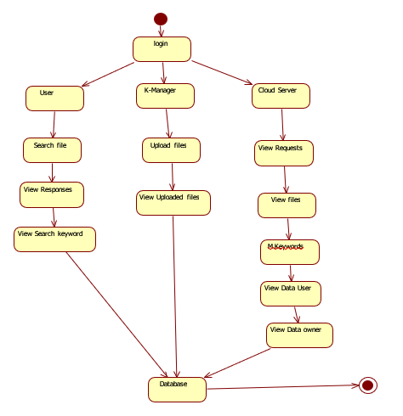
State diagram are a loosely defined diagram to show workflows of stepwise activities and actions, with support for choice, iteration and concurrency. State diagrams require that the system described a user has a login. After it has performs an actions. K-Manager has login. Can have an upload data and view uploaded data operation. Cloud server has also perform an actions it will have an actions on a database.

3.2.9 ACTIVITY DIAGRAM
User
K-Manager
Cloud Server
Search File
View Responses
View search Keyword
Upload File
View Uploaded files
View Requests
View Files
M.Keywords
View Data Users
View Data owners
Database

Activity diagrams are graphical representations of workflows of stepwise activities of a data user data owner and cloud server actions with support for choice, iteration and concurrency. In the Unified Modeling Language, activity diagrams can be used to describe the business and operational step-by-step workflows of components in a system. User can also a search a file view a responses file and it will search with a keyword. K-Manager can also an upload a file and then view uploaded file the information was a gather at a database. Cloud server can also have a view request view files and matched keyword it was perform at step wise manner. An activity diagram shows the overall flow of control.

3.3 DATA FLOW DIAGRAM
Level 0
Register
Home Page
Login
Verify Details
Data base
Error page

Level 1
Keys
Attacker details
Data user request
Search Files
Login
User
Cloud Server
Data base
Upload Files
K-Manager
Requested Files
Login
Data user Information
Files
Login

A data flow diagram (DFD) is a graphical representation of the "flow" of data through an information system, modeling its process aspects. Often they are a preliminary step used to create an overview of the system which can later be elaborated. DFDs can also be used for the visualization of data processing (structured design). A DFD shows what kinds of data will be input to and output from the system, where the data will come from and go to, and where the data will be stored. User can also a login. User can have a search keyword and have a requested files. K-Manager can also have a login. Manager can also have an uploaded file and data user request. Cloud server can also a login. Cloud server can also have a Manager Information users information data .Cloud server can also have a keys. Cloud server can also have a file attacker details. All information is gather and store at a database.
3.4 E-R DIAGRAM
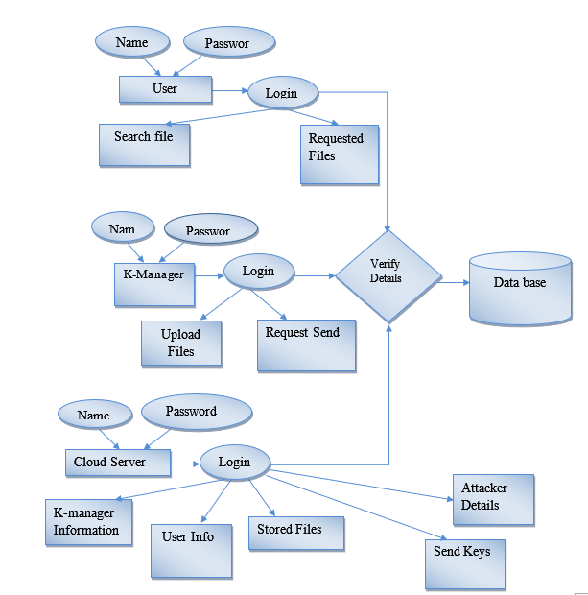

Entity-Relationship Model (ERM) is a user has a username and password if the user name and password has a correct then it will login. After login data user can search file and have a requested file. K-Manager has a username and password the username and password has correct it will verify with a database. Manager can also have an upload a files and then have a requested send. Cloud server can also have a username and password user name and password has a correct it will verify from the database. Cloud server can also have a data owner information. Cloud server can also have a data user information. Cloud server can also have a stored a files information details. Cloud server can also have a send keys. Cloud server can also have an attacker details.

CHAPTER 4
RESULTS & DISCUSSION
Home page:
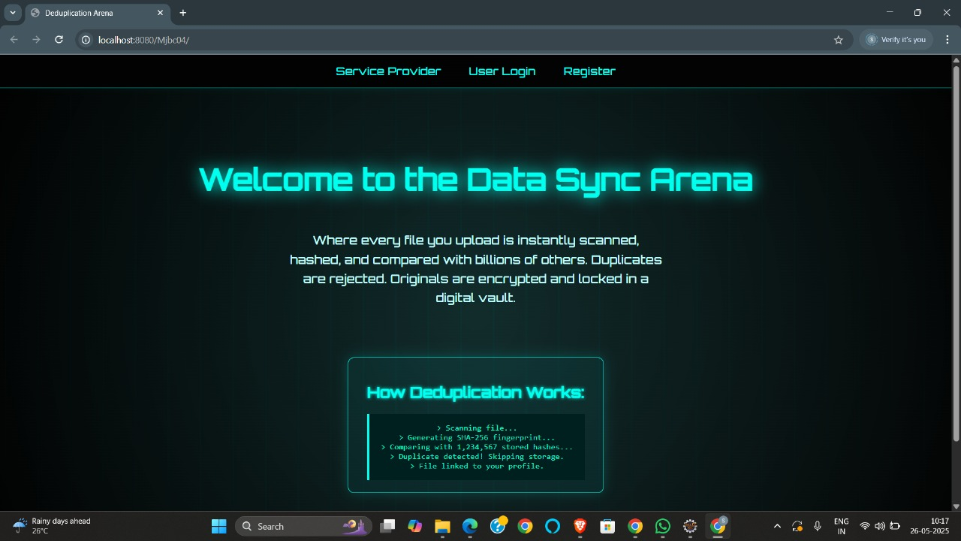
The image showcases a web-based interface titled "Deduplication Arena", which is focused on efficient data management through deduplication. The application aims to optimize storage by scanning and identifying duplicate files using SHA-256 hashing. Once a file is uploaded, it’s fingerprinted and compared against a vast database of existing hashes. If a match is found, the file is flagged as a duplicate and not stored again, conserving space while still linking it to the user’s profile.
The interface features a sleek, cyber-themed design with glowing neon text and a dark background, evoking a futuristic and secure digital environment. Key navigation options—Service Provider, User Login, and Register—are accessible from the top bar, allowing different users to interact with the system based on their roles.
Data Owner Registration Page: 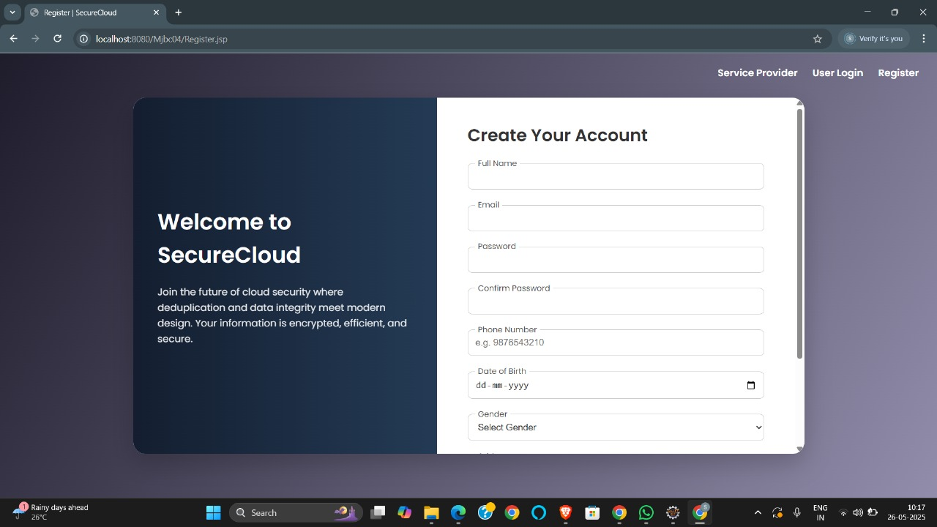
The image presents the registration interface of the "SecureCloud" platform, a web-based solution focused on enhancing cloud security through deduplication and data integrity. The screen is neatly divided into two sections, offering both aesthetic appeal and functional clarity.
On the left side, there’s a welcome message introducing users to SecureCloud. It emphasizes the platform’s vision of secure, encrypted, and efficient data handling by combining cutting-edge deduplication methods with modern user experience design. This messaging sets the tone for a security-first approach to cloud data management.
On the right side, a clean and modern "Create Your Account" form is provided for new users. It collects essential details such as full name, email, password (with confirmation), phone number, date of birth, and gender. The layout is user-friendly and intuitive, supporting ease of onboarding.

Data Owner Homepage:
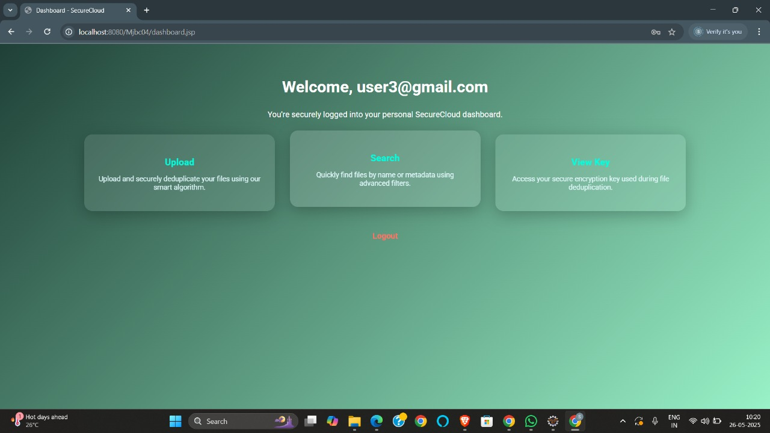

The image displays the user dashboard of the SecureCloud application, a platform built to enhance cloud security through intelligent file deduplication and encryption. This dashboard interface appears after successful login and serves as the central control panel for the user.
The dashboard presents three main functional options, each placed inside clearly defined cards:
- Upload – Allows users to upload their files, where they are automatically scanned and deduplicated using the platform’s smart algorithm to optimize storage.
- Search – Lets users quickly locate previously uploaded files using file names or metadata, supported by advanced filtering tools.
- View Key – Gives users access to the unique encryption key associated with their file deduplication, reinforcing data ownership and security.

Data Owner Upload
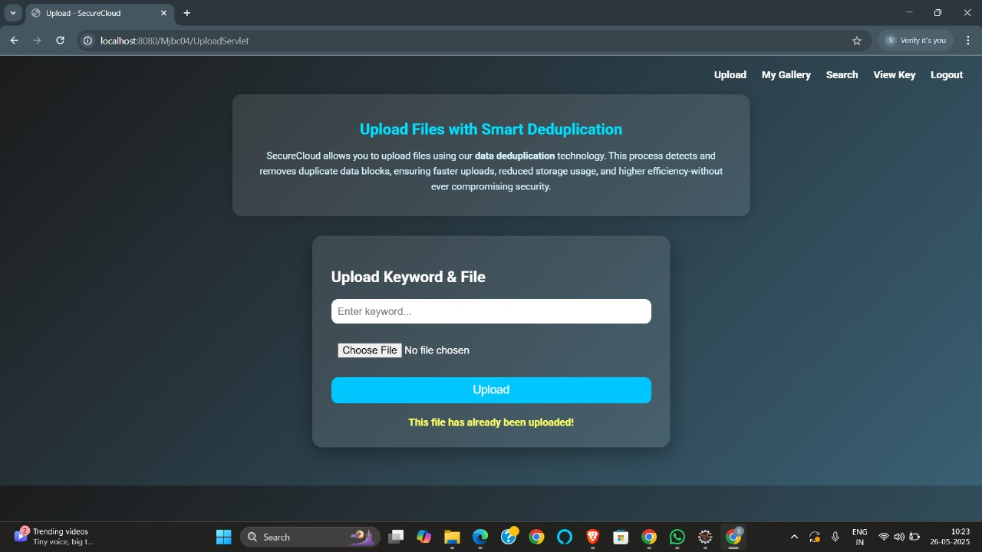
The image showcases the file upload interface of SecureCloud, a web application focused on smart data deduplication to optimize cloud storage and ensure secure file management. This page specifically enables users to upload files with the assurance that duplicates will be automatically detected and excluded.
At the top of the page, there's a clear title—"Upload Files with Smart Deduplication"—followed by a brief description. It explains how SecureCloud leverages deduplication technology to eliminate redundant data blocks. This results in faster uploads, better storage utilization, and increased overall efficiency, all while maintaining robust data security.
Data Owner send Keys to User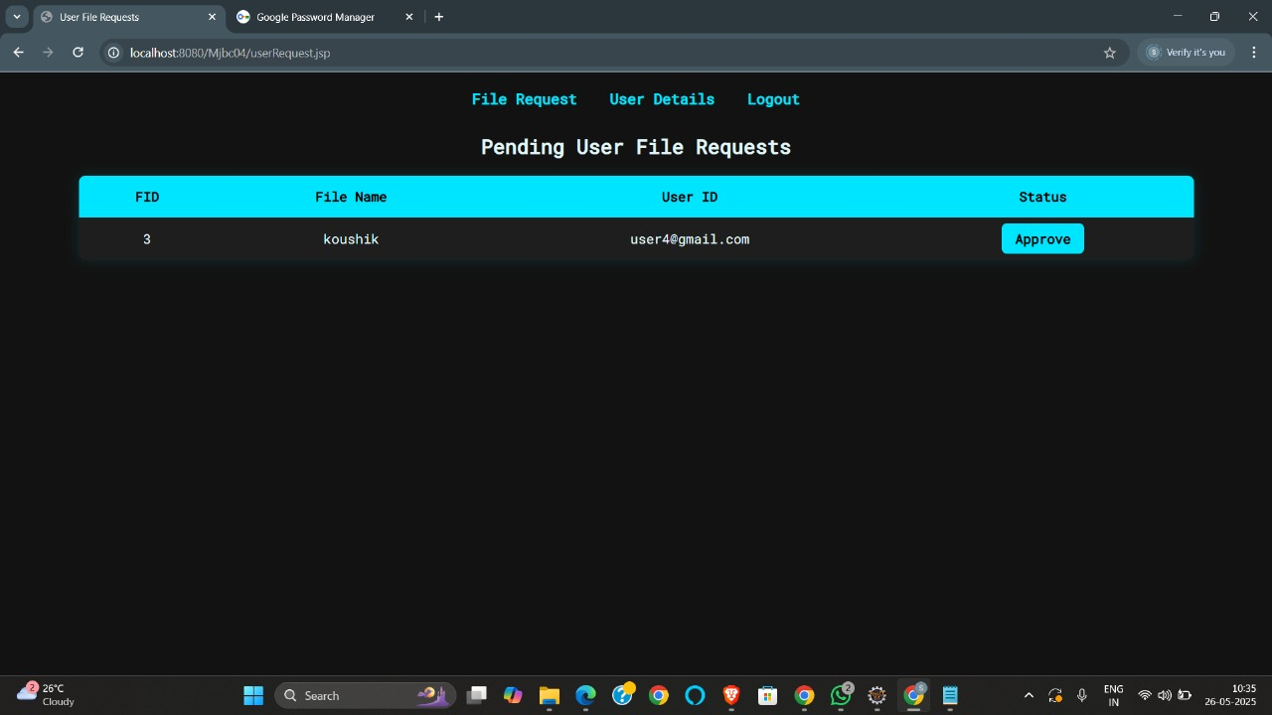

The displayed interface is the admin or service provider panel of the SecureCloud application, specifically showing the "Pending User File Requests" page. This section is designed to manage and control user access to uploaded files within the cloud system. It lists all the pending requests from users who want to access specific files, displaying relevant details such as the File ID, File Name, the requesting User ID (email), and an "Approve" button to authorize access. The navigation bar at the top includes options like File Request, User Details, and Logout, allowing the admin to move between different sections of the dashboard.

Data User Registration Page
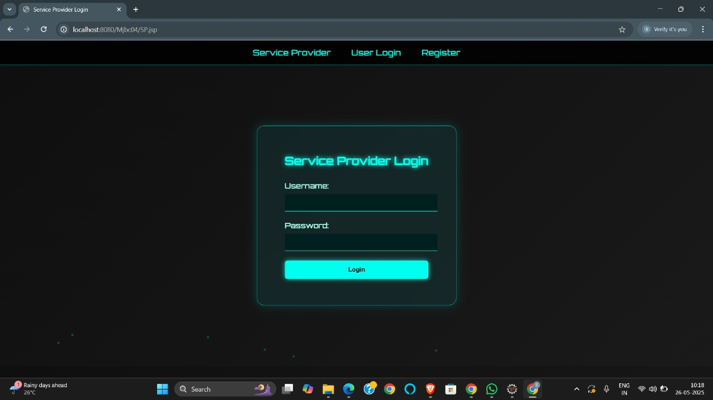

The image shows the "Service Provider Login" page of the SecureCloud application, designed specifically for administrators or service providers to securely access their dashboard. The page contains input fields for the username and password, along with a "Login" button to authenticate the user.

Data User Search Query Page
The dashboard offers a clean and user-friendly interface with a welcoming message at the top, confirming the secure login. It provides three main functionalities: Upload, which allows users to securely upload and deduplicate files using a smart algorithm; Search, enabling users to quickly locate files through name or metadata with advanced filters; and View Key, which grants access to the encryption key used during file deduplication. A Logout option is clearly provided below these features, ensuring users can securely end their session.
Data User Request Page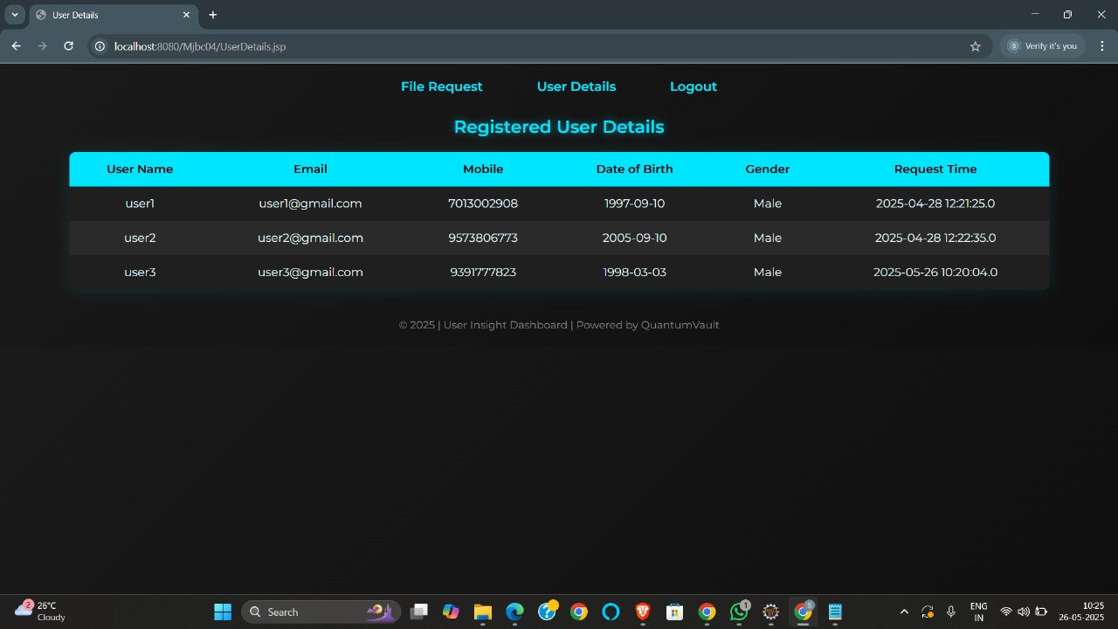

This interface lists all users who have registered on the platform, displaying key information in a tabular format. Each row presents details such as the User Name, Email, Mobile Number, Date of Birth, Gender, and the exact Request Time when the user registered or made a request. The page offers navigation links at the top for "File Request," "User Details," and "Logout," allowing easy movement between different administrative functionalities.

Data User Download Page
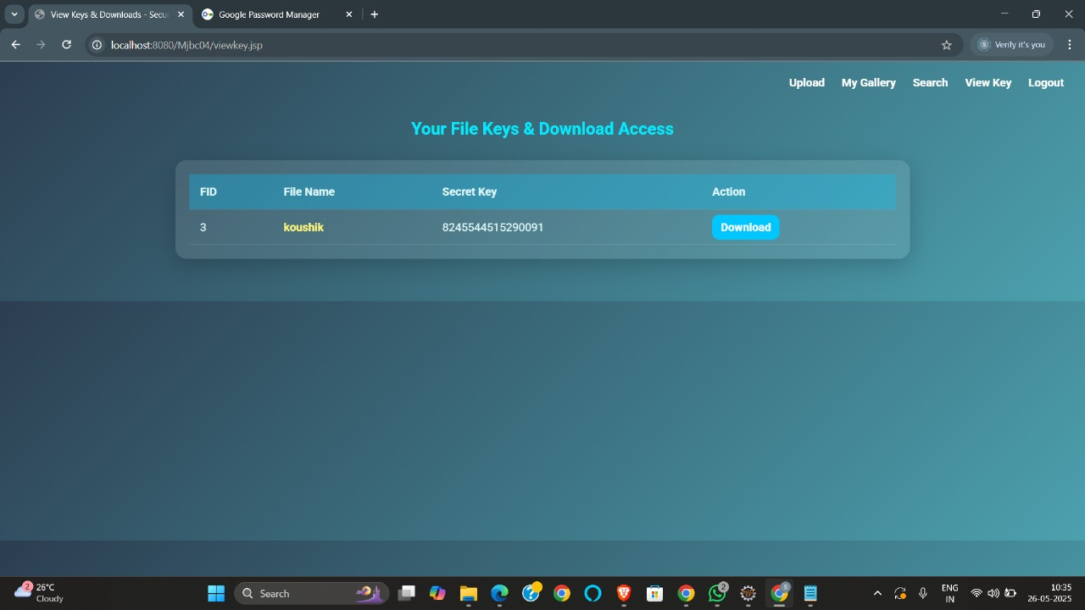
The image displays the “View Key” page of the SecureCloud platform, where users can access encryption keys associated with their uploaded files. The interface provides a table with columns for FID (File ID), File Name, Secret Key, and Action. In the given example, a file named “koushik” is listed with a unique secret key (8245544515290091), which is likely used for secure access or decryption of the file. The Download button in the Action column allows users to retrieve the file directly.

CHAPTER 5
5.1 CONCLUSION
In this paper, we concentrate on the issue of scrambled information deduplication and propose a TCD-DBSCAN calculation. The concept of bunching deviation is proposed, and our calculation is applied in the deduplication cycle to decrease the gamble of inner information spillage. Untimely change of disagreeable information is killed regardless of whether the information are transferred by clients from a similar association. For disagreeable information, symmetric encryption is taken on and the encryption key is acquired by blind mark convention, between the vital chief and the clients. So that, deduplication of disagreeable information can be accomplished without client passing their keys on the web, which further works on the efficiency of deduplication. Security examination what's more, execution assessment exhibit that the proposed conspire is secure and of incredible down to earth esteem.
5.2 FUTURE ENHANCEMENT
With regards to hierarchical administration, as the innovation proposed in this paper turns out to be all the more generally embraced, various information handling modules connected with provider item strategies, costs, energy utilization, and different elements can be coordinated to additionally enhance the computerized aeronautics supply quality administration framework.

5.3 REFERENCES
[1] Y. Fan, X. Lin, W. Liang, G. Tan, and P. Nanda, ‘‘A secure privacy preserving deduplication scheme for cloud computing,’’ Future Gener. Comput. Syst., vol. 101, pp. 127–135, Dec. 2019. [2] Z. Yan, W. Ding, X. Yu, H. Zhu, and R. H. Deng, ‘‘Deduplication on encrypted big data in cloud,’’ IEEE Trans. Big Data, vol. 2, no. 2, pp. 138–150, Jun. 2016.
[3] Y. Zhai, M. Ibrahim, Y. Qiu, F. Boemer, Z. Chen, A. Titov, and A. Lyashevsky, ‘‘Accelerating encrypted computing on Intel GPUs,’’ in Proc. IEEE Int. Parallel Distrib. Process. Symp. (IPDPS), May 2022, pp. 705–716.
[4] X. Yang, R. Lu, J. Shao, X. Tang, and A. A. Ghorbani, ‘‘Achieving efficient and privacy-preserving multi-domain big data deduplication in cloud,’’ IEEE Trans. Services Comput., vol. 14, no. 5, pp. 1292–1305, Sep. 2021.
[5] C. Guo, X. Jiang, K.-K.-R. Choo, and Y. Jie, ‘‘R-dedup: Secure client-side deduplication for encrypted data without involving a third-party entity,’’ J. Netw. Comput. Appl., vol. 162, Jul. 2020, Art. no. 102664.
[6] X. Tang, L. Zhou, B. Hu, and H. Wu, ‘‘Aggregation-based tag deduplication for cloud storage with resistance against side channel attack,’’ Secur. Commun. Netw., vol. 2021, pp. 1–15, Feb. 2021.
[7] J. R. Douceur, A. Adya, W. J. Bolosky, P. Simon, and M. Theimer, ‘‘Reclaiming space from duplicate files in a serverless distributed file system,’’ in Proc. 22nd Int. Conf. Distrib. Comput. Syst., 2002, pp. 617–624.
[8] L. Wang, B. Wang, W. Song, and Z. Zhang, ‘‘A key-sharing based secure deduplication scheme in cloud storage,’’ Inf. Sci., vol. 504, pp. 48–60, Dec. 2019. [9] Y. Zhao and S. S. M. Chow, ‘‘Updatable block-level message-locked encryption,’’ in Proc. ACM Asia Conf. Comput. Commun. Secur., Apr. 2017, pp. 449–460.
[10] H. Yuan, X. Chen, J. Li, T. Jiang, J. Wang, and R. H. Deng, ‘‘Secure cloud data deduplication with efficient re-encryption,’’ IEEE Trans. Services Comput., vol. 15, no. 1, pp. 442–456, Jan. 2022.
[11] J. Stanek, A. Sorniotti, E. Androulaki, and L. Kencl, A Secure Data Deduplication Scheme
for Cloud Storage. Berlin, Germany: Springer, 2013.

